Retail management application using

salesfoce

1. INTRODUCTION:

1.1 Overview:

This is the process that facilitates easy procurement of desired merchandise from retail stores for the sole purpose of the sole purpose of personal consumption. It is an elaborate process that includes multiple steps for attracting the customer to the steps for attracting the customer to the store and then meeting their needs and requirements.

1.2 Purpose:

Retail management refers to the process of helping customers find products in your store.

It includes everything from increasing your customer pool to how products are presented, and how you fulfill a customer’s needs.

A good store manager helps customers leave the store with a smile.

**Problem Definition & Design Thinking**

**2.1 Empathy map:**

An empathy map is a collaborative visualization used to articulate what we know about a particular type of user. It externalizes knowledge about in order to

1) Create a shared understanding of user needs, and

2) Aid in decision making

EMPATHY MAP

|  |  |
| --- | --- |
| PROJECT NAME | RETAIL MANAGEMENT APPLICATION I USING SALESFORCE |
| TEAM ID | NM2023TMID17822 |
| DATE | 21.3.2023 |

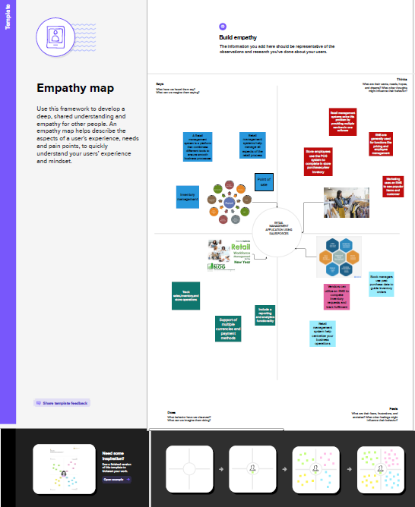

2.2 Brainstorming :

Brainstorming is a group problem-solving method the involves

the spontaneous contribution of creative ideas and solutions. This te3chniqued

requires intensive, freewheeling discussion in which every number of the group is

encouraged to think aloud and suggest as many ideas possible based on their

diverse knowledge.

|  |  |
| --- | --- |
| PROJECT NAME | RETAIL MANAGEMENT APPLICATION USING SALESFORCE |
| TEAM ID | NM2023TMID17882 |
| DATE | 21.3.2023 |
| NAME | YAMUNA.P |

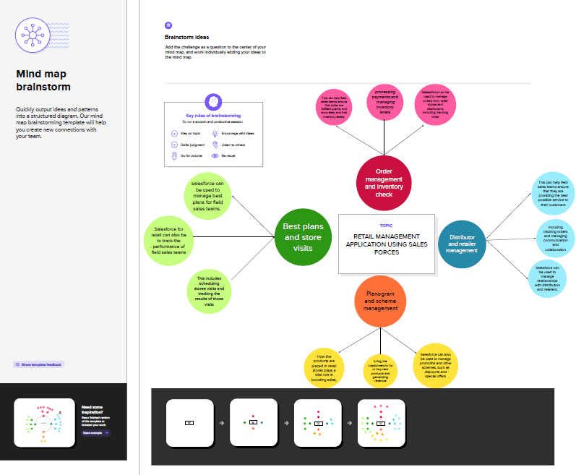

**RESULT**

**3.1 Date model:**

|  |  |  |  |  |
| --- | --- | --- | --- | --- |
| Object name | | | Field label | Data type |
| 1 | Dispatch/Tracking | | Dispatch/Tracking | Text |
| Recent | | Recent | Text |
| 2 | Accounts | | Accounts | Text |
| Products | | Products | Text |
|  |

**3.2 Activity & Screen short:**

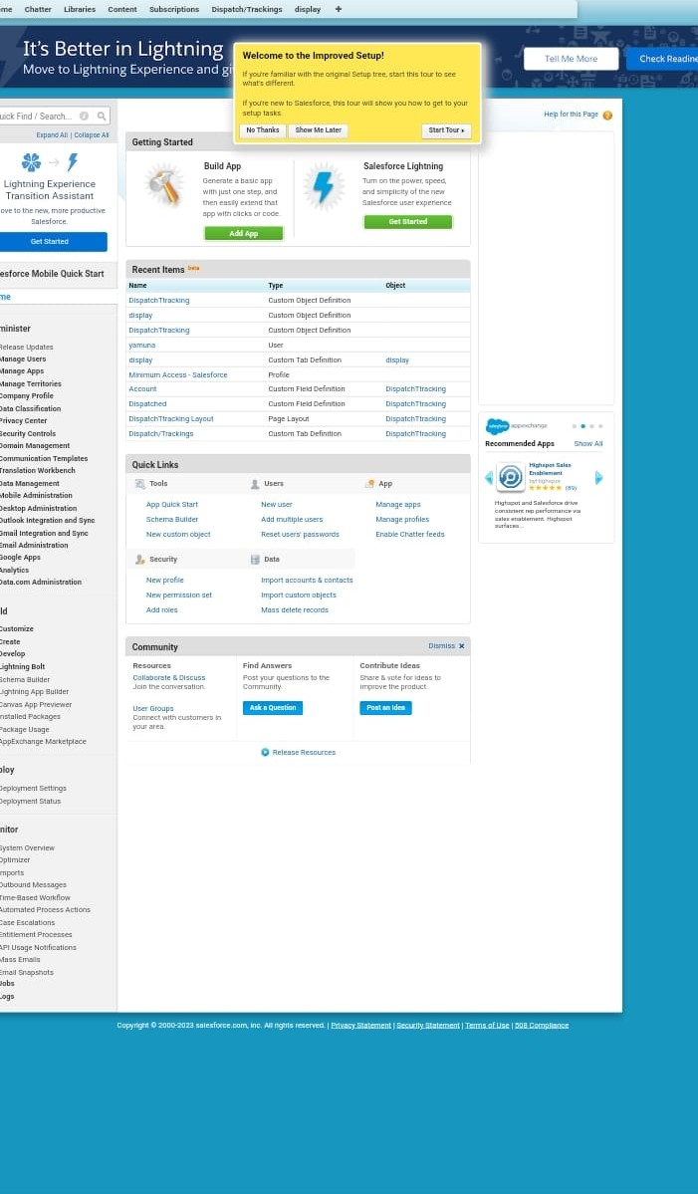

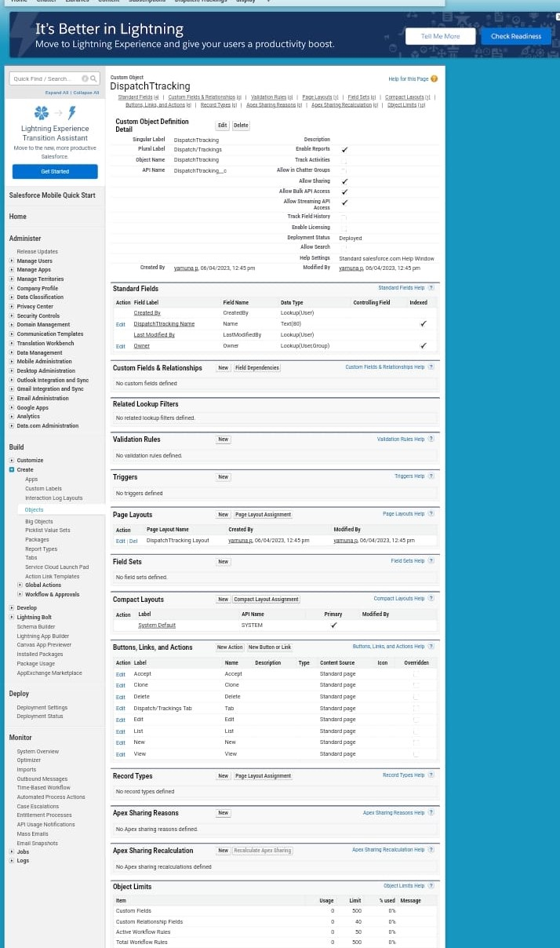

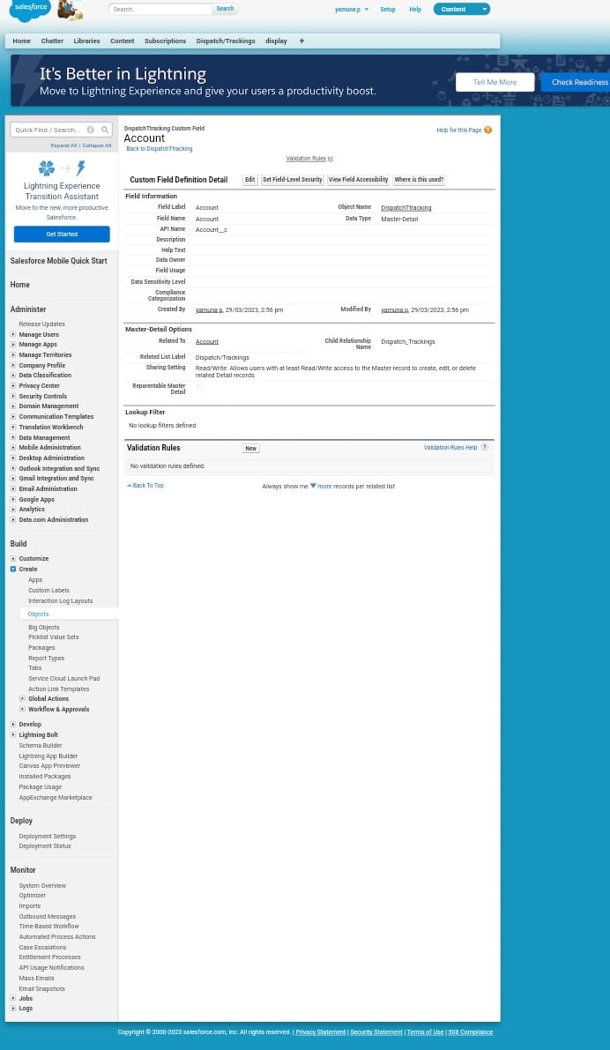

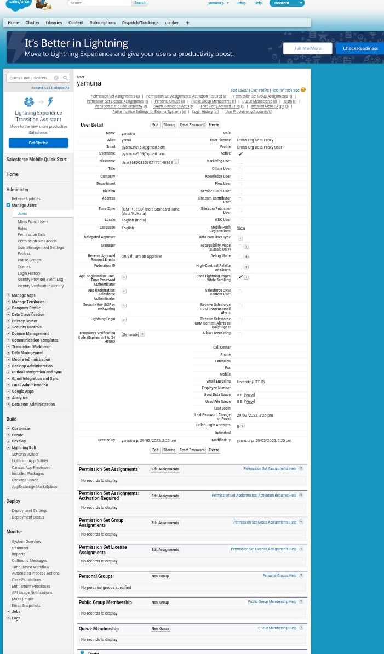

**4.TRAILHEAD PROFILE PUBLIC URL**

Team Leader -https://trailblazer.me/id/yamuna11

Team Member 1- https://trailblazer.me/id/bhanm7

Team Member 2- https://trailblazer.me/id/viswk5

Team Member 3-https://trailblazer.me/id/yuvaraj63

**5.ADVANTAGES & DISADVANTAGES**

**Advantages:**

Requires Less Capital

More profit margin than wholesalers

Better customer relation credit facility

No liability towards the buyers

**Disadvantages:**

Requires more marketing costs

Good selling skill is required

High competition

No benefit of bulk buying

**6. APPLICATIONS**

A retail app is simply a software that lest sellers and buyers transact their business online.

Apps for retail business are a gold mine when it comes to improving shopping.

Shop owners are now able to obtain important information about clients so as lead them into purchasing.

**7. CONCLUSION**

Retailing thus enjoys many unique features. Inefficiency in retailing leads to lower profitability of the retailers and lower service outputs for the consumers. Steps to strengthen the position of the retailing industry must be taken. Such steps may include establishment of retailer’s co-operatives, merger and buy-out, use of technology to the greatest possible extent, setting up of non-store retailing centers and increase in franchisee network.

**8. FUTURE SCOPE**

The project a very vast scope in future. The project be implemented on internet in future.